Name: Ameer Edzzad Shah
Student ID: 22005680
Group: G8
Lab 05: HR Analytics Dashboard Report
1. Dataset Description
The dashboard uses the HR Analytics Dataset from Kaggle, which includes employee details such as age, gender, department, job role, income, satisfaction, and attrition. It contains 1,480 records and 34 attributes, divided into numerical (e.g., Age, MonthlyIncome, YearsAtCompany) and categorical variables (e.g., Department, Gender, JobRole, Attrition). The dataset supports analysis of workforce trends, salary patterns, and employee turnover.
2. Visualization Description
The dashboard includes several visuals:
KPI Cards: Show Total Employees, Attrition Rate, Average Income, and Job Satisfaction for quick insights.
Bar Chart (Employees by Department): Compares employee counts across departments.
Column Chart (Income by Job Level): Shows how salary increases with job level.
Scatter Chart (Income vs Years at Company): Displays the relationship between experience and income.
Stacked Bar Chart (Attrition by Department): Highlights attrition patterns across departments.
Column Chart (Age Distribution): Shows employee distribution by age group.
Treemap (Employees by Job Role): Displays the size of each job role category.
3. Key Insights
Research and Development has the highest number of employees, while HR has the least.
Attrition varies across departments and roles, indicating uneven employee turnover.
Higher job levels are associated with higher income.
Longer tenure often relates to higher income, though not always.
The workforce includes a mix of age groups with different needs and priorities.
4. Interactive Features
The dashboard includes slicers for Department, Gender, and Job Role, allowing users to filter data easily. Visual-level and page-level filters are also used to focus analysis, such as viewing only Sales employees or employees with Attrition = Yes. These features improve flexibility and user interaction.
5. Reflection
A key challenge was selecting appropriate visuals and correctly assigning fields in Power BI. This project helped develop skills in data import, visualization creation, filtering, and dashboard design. Future improvements could include advanced visuals like Key Influencers and additional pages for deeper analysis.
6. Conclusion
The HR dashboard provides insights into employee distribution, salary trends, and attrition. Interactive features allow users to explore data effectively, supporting better HR decision-making.
7. Appendix
Default chart with no formatting:
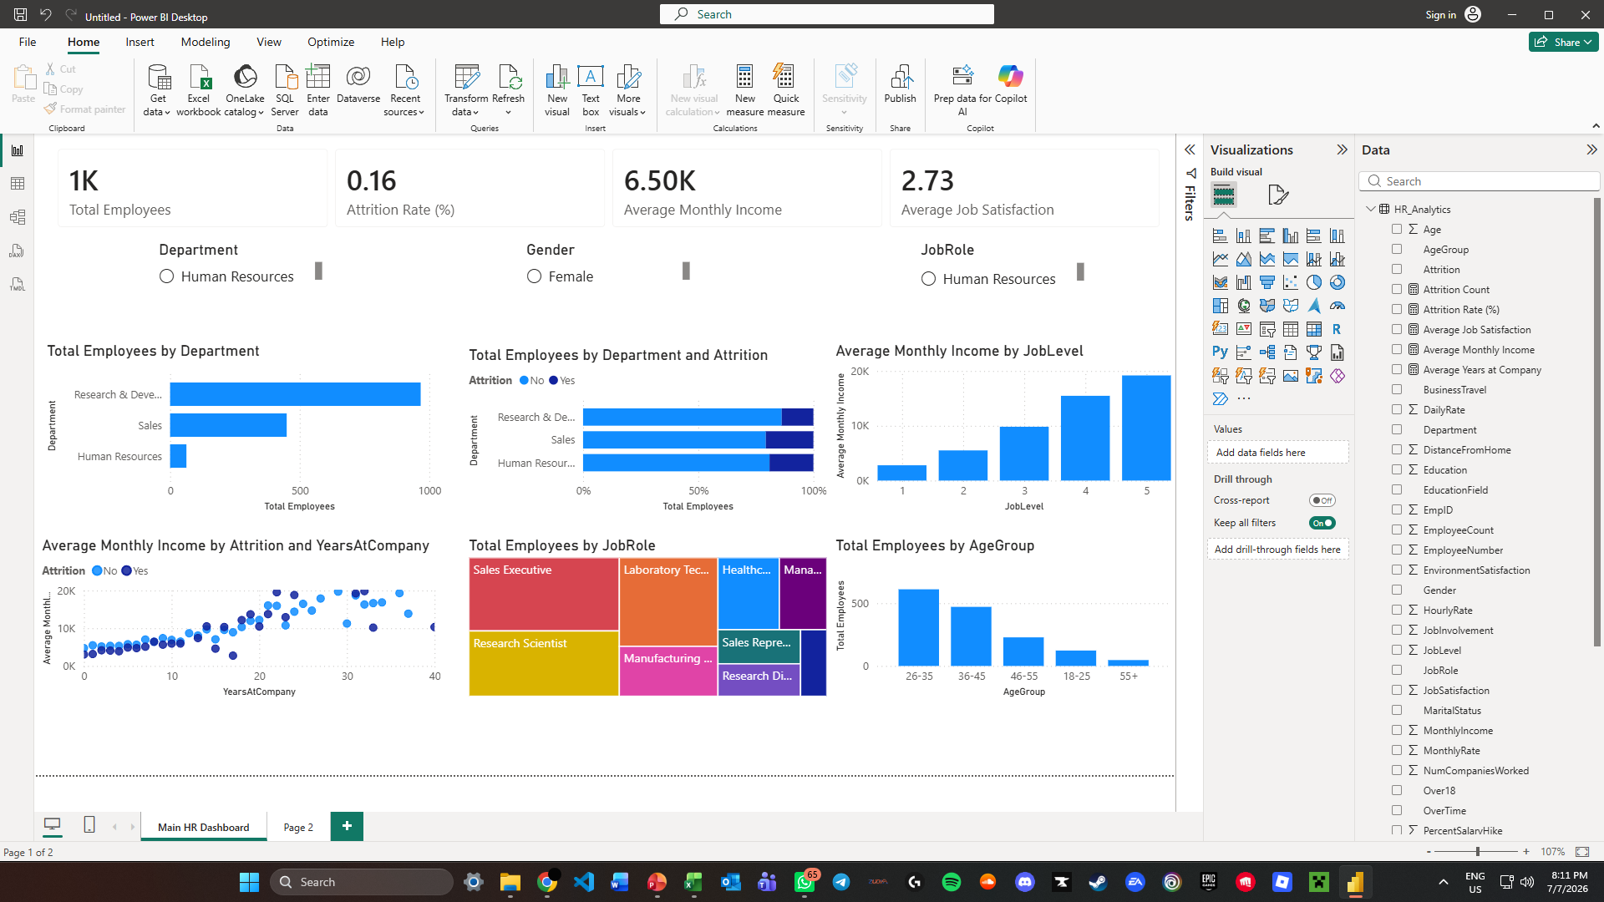
Chart with title, colours, labels, and sorted values:
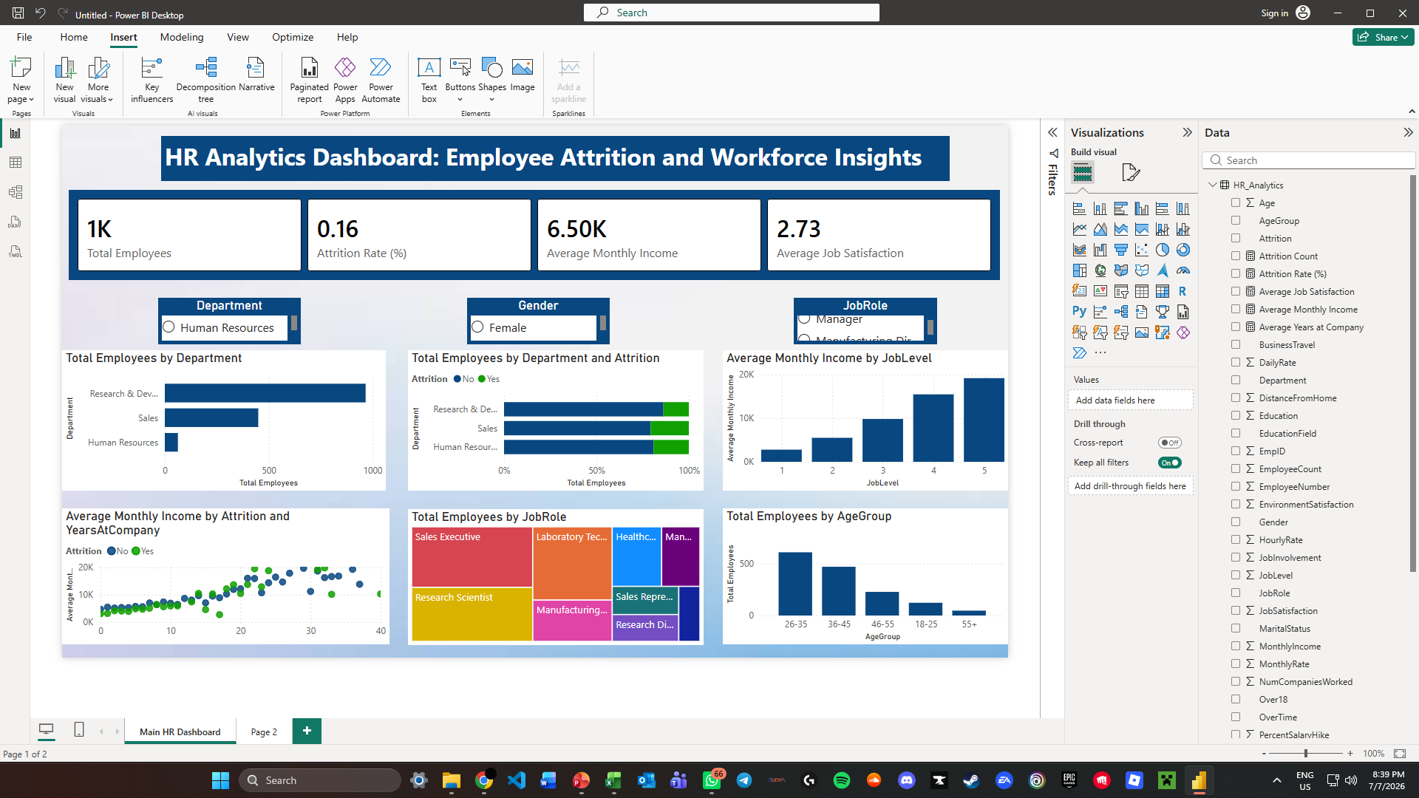

Dashboard before and after selecting Department/Gender/JobRole:
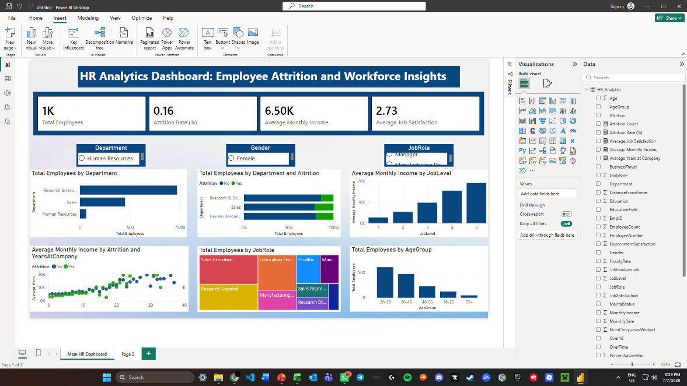
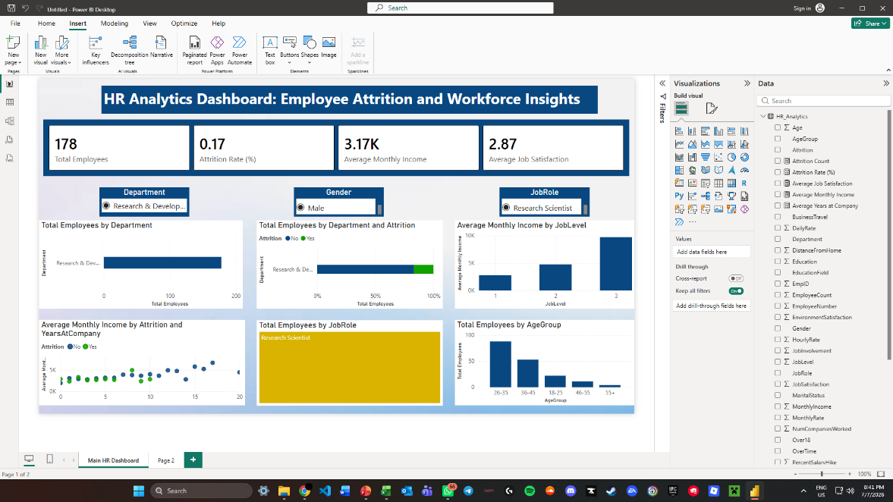

Before and after applying sales filter:
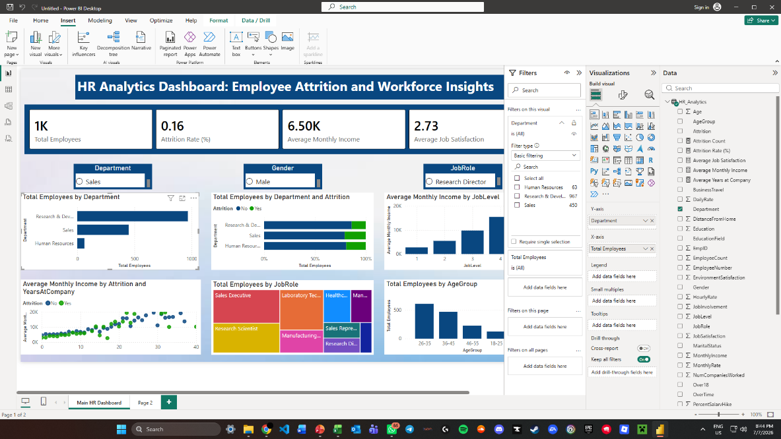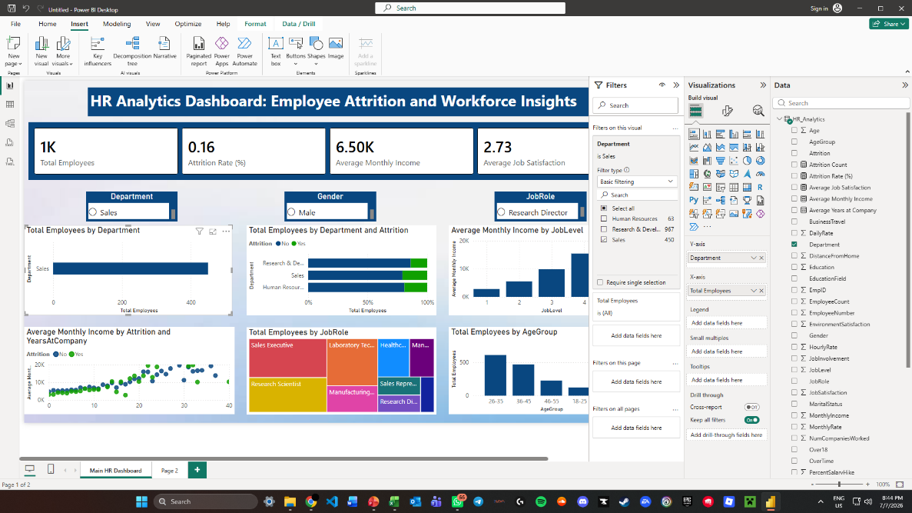

Dashboard before page filter, dashboard after Attrition = Yes page filter:
